Experiment 7
Subnetting & IP Assignment

Lab 7 Objectives:
● Perform subnetting calculations and assign appropriate IPs to networked systems.
Prerequisites: The prerequisites of this lab are-
● Basic understanding of IP addressing and subnetting.
● Familiarity with binary conversion and subnet mask calculations.

Outcomes: By the end of this lab, students will be able to:
● Calculate subnet masks and determine network and host ranges.
● Assign IP addresses to devices based on subnet requirements.
● Verify network connectivity and troubleshoot IP conflicts.

Step 1: Determine Subnet Requirements

Given network: 192.168.10.0/24
Requirement: Divide this network into 4 subnets with at least 50 hosts per subnet.
- Number of subnets required = 4
- Minimum hosts per subnet = 50

Step 2: Calculate the Subnet Mask

Default Information
- The IP address 192.168.10.0 is a Class C IP address.
- Default subnet mask for Class C is 255.255.255.0 or /24.
- This means 8 bits are available for host addresses (last octet).
Calculate number of bits to borrow for subnetting
To create 4 subnets:

2^{n} ≥ 4 ⟹ n = 2 bits borrowed

- Borrow 2 bits from the host portion for subnetting.
- Remaining bits for hosts = 8 - 2 = 6 bits.

Calculate maximum hosts per subnet

2⁶− 2 = 64 – 2 = 62 usable hosts per subnet

(2 addresses are reserved for network address and broadcast address)
Since 62 ≥ 50, this subnet mask satisfies the host requirement.

Calculate the new subnet mask
- Borrowing 2 bits means the new subnet mask is:

255.255.255.(256−2⁸−²)=255.255.255.192

- In CIDR notation, this is /26.

Step 3: Find Subnet Addresses and Usable IP Ranges
Each subnet has 64 IP addresses (including network and broadcast addresses).
Subnet | Network Address | Usable Host IP Range | Broadcast Address
1 | 192.168.10.0 | 192.168.10.1 – 192.168.10.62 | 192.168.10.63
2 | 192.168.10.64 | 192.168.10.65 – 192.168.10.126 | 192.168.10.127
3 | 192.168.10.128 | 192.168.10.129 – 192.168.10.190 | 192.168.10.191
4 | 192.168.10.192 | 192.168.10.193 – 192.168.10.254 | 192.168.10.255

Step 4: Assign IP Addresses to Devices
Assign unique IP addresses within the usable range to each device on a subnet. For example:
Device | Subnet | Assigned IP | Subnet Mask
PC1 | 1 | 192.168.10.1 | 255.255.255.192 (/26)
PC2 | 1 | 192.168.10.2 | 255.255.255.192 (/26)
PC3 | 2 | 192.168.10.65 | 255.255.255.192 (/26)
PC4 | 3 | 192.168.10.130 | 255.255.255.192 (/26)

Step 5: Configure and Verify IP Settings
- Configure IP addresses and subnet masks on devices.
- To check IP configuration on Windows, use the command:

ipconfig /all
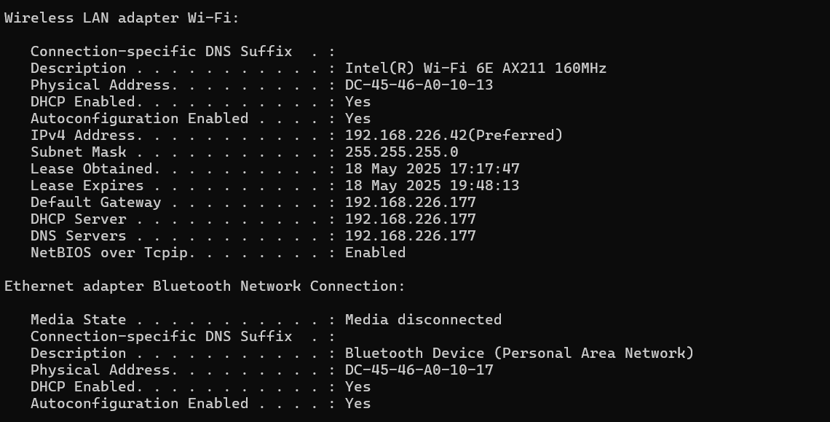

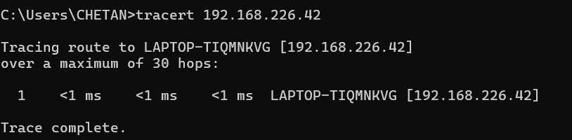
Use tracert (Windows)

Step 6: Troubleshoot IP Conflicts and Connectivity Issues
If ping fails, check the following:
- IP address and subnet mask are configured correctly.
- No duplicate IP addresses on the network.
- Network cables or virtual links are connected properly.
- Devices are powered on and reachable.

